READ NOW: Pressure and Depth in Fluids Date: 2/12/2025
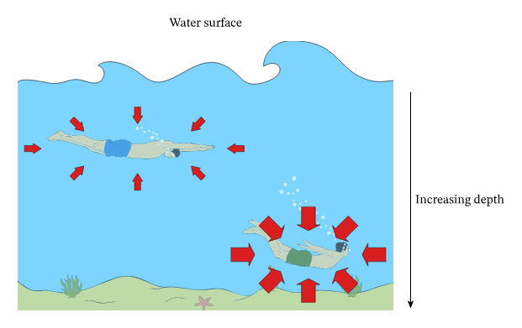
When you go deeper into a fluid, such as water, the pressure increases. This happens because there is more fluid above you, and that fluid has weight. The deeper you are, the more weight is pushing down on you from above.
Pressure in a fluid depends on three things:
- how deep you are (the depth),
- the density of the fluid,
- and the gravitational field strength.
The bigger the depth or the density, the greater the pressure will be. This is why deep oceans have very high pressure compared to shallow water. At the surface, the pressure is low because there is less water pressing down.
So, the key idea is: as depth increases, pressure increases because there is more fluid above the point, pushing down with greater force.

Questions
- What happens to pressure when you go deeper into a fluid?
- Why does pressure increase as depth increases?
- Name one factor that pressure in a fluid depends on.
- Why is pressure higher at the bottom of the ocean than near the surface?
Drill
- What is a fluid?
- Why can liquids be used in hydraulic systems?
- A box pushes down on the floor with a force of 200 N. The area of the bottom of the box is 0.5 m².
Calculate the pressure the box exerts on the floor and write the units.
Use: pressure = force ÷ area

